Certificate of Approval of a Base Prospectus

pursuant to Prospectus Regulation (EU) 2017/1129 of the European Parliament and of the Council
Certificate Reference 00380501

To: Finanzmarktaufsicht, Austria
Financial Services and Markets Authority, Belgium
Finanstilsynet, Denmark
Finanssivalvonta, Finland
Autorité des Marchés Financiers, France
Bundesanstalt für Finanzdienstleistungsaufsicht, Germany
Central Bank of Ireland, Ireland
Commissione Nazionale per le Societa e la Borsa, Italy
Commission de Surveillance du Secteur Financier, Luxembourg
Autoriteit Financiële Markten, the Netherlands
Finanstilsynet, Norway
Comisión Nacional del Mercado de Valores, Spain
Finansinspektionen, Sweden

From: Financial Conduct Authority, United Kingdom

[We hereby certify that the Base Prospectus detailed below has been drawn up pursuant to Prospectus Regulation (EU) 2017/1129 of the European Parliament and of the Council and was approved by us on 20/11/2020.

Name of Issuer(s): WisdomTree Metal Securities Limited

LEI: 213800QFA5KMBW5CVX71

Registered Office(s): Jersey

Type of Securities (if applicable): Prospectus relating to the issue of Metal Securities

National Prospectus Identifier: PRO05537
(references to the annexes of Regulation used): 9,14,17,19 & 22
Name of the Guarantor(s) (if any): N/A

We have authorised, in accordance with Article 18 of Prospectus Regulation (EU) 2017/1129, the omission of the information required on the following grounds: No omission

FCA Stamp:
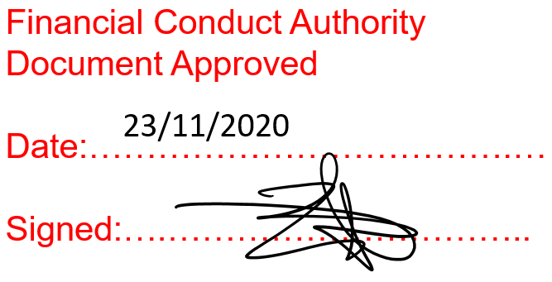

For and on behalf of the Financial Conduct Authority

Date: 23/11/2020

Attachments: (1) Base Prospectus

This Certificate of Approval relates to a Prospectus which does not consist of separate parts, as referred to in Article 10 of Prospectus Regulation (EU) 2017/1129.
For use only in respect of Prospectuses which do not consist of separate parts, as referred to in Article 10 of the Prospectus Regulation (EU) 2017/1129.

